Project number: 1.1.1.2/VIAA/2/18/348
Full name: Mohcine Boudhane
Position: Researcher
Project title: The Study of Computer Vision Algorithms for Underwater Fish Inspection

Visibility problems and underwater image enhancement methods:

Image preprocessing can greatly increase the reliability of an optical image. In this part, we describe recent methods of denoising and enhancement of underwater optical images.

Enhancing image quality involves improving the visual perception of the signal by transforming its components while avoiding generating artifacts or amplifying existing defects and distortions.

Most often, this operation is accompanied by some undesirable effects such as amplification of the noise or the saturation effect in certain sensitive areas in the case of contrast enhancement. Eliminating noise or reducing artifacts such as block effects in JPEG-compressed images inevitably cause blurring and degrade image quality. It is therefore important to control and think about these unpredictable effects in the design of image quality enhancement methods.

Generally, image enhancement can be done in:
- Special domain
- Frequency domain

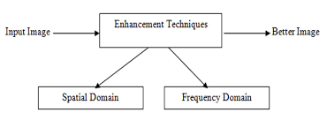

Frequency domain:
example: low/ high pass filter, pseudo color image processing, homomorphing filter.

Spatial domain transformation are:
- Point processing
- Histogram processing
- Neighborhood processing

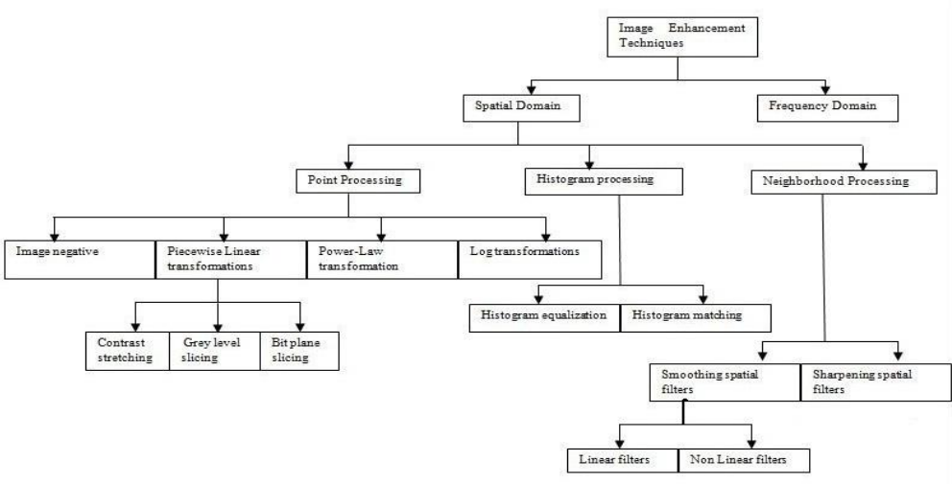

Different optimization criteria will be chosen, depending on the use or the subsequent processing of the image, as well as the knowledge that one can have a priori of this image.

Degradations suffered by an image can be caused by different phenomena (measurement noise, camera shake ...). The restoration algorithms will differ according to the type of degradation observed, in particular depending on the system chosen to model the degradation. This model can be simply the addition of a noise (measurement noise, or transmission noise), or the convolution of the original image with a function representing the degradation. This function can model a variety of impairments such as camera shake, defocus or diffraction of the camera, and so on. It is usually referred to in the "Point Spread Function" (PSF) [1].

As follows recent image enhancement methods underwater in the litterature, we distinguish two big classes:

- Non-model-based methods
- Prior based methods

Non-model-based methods :

Method | Enhancement technique
UCM[2] | Unsupervised color balance and histogram stretching
MSRCR[3] | Multiscale retinex with color restoration
CLAHE[4] | Contrast-limited adaptive histogram equalization
CLAHE-MIX[5] | Mixture RGB and HSV CLAHE
Fusion[6] | White Balance, bilateral filtering, image fusion
Ghani[7] | minimizes under-enhanced and over-enhanced areas
Prior-based methods
Method | Physical prior
BP[8] | Radiance attenuation
P.Drews-Jr[9] | Underwater DCP on g,b
UHP[10] | Color distribution
ENOM[11] | Underwater DCP
Li[12] | Underwater DCP
LDP[13] | Histogram distribution prior
Peng [14] | Blurriness& Light Absorption
WCID[15] | Residual energy ratios
Galdran[16] | Red channel prior
Lu[17] | UDCP with median filter
Li[18] | UDCP with median filter
Yang[19] | UDCP with median filter
DPATN[20] | Learning-based UDCP

Discussion:

Unlike conventional natural images taken in the open air, underwater images are characterized by a strong dominance of bluish and greenish colors. Moreover, the strong light attenuation in the water and a high diffusion of the incident light have the consequence of considerably reducing the visibility. Thus, objects at long distance from the acquisition system are hardly visible and poorly contrasted in relation to their environment, but also at medium distances, or even relatively short in some cases. In addition, in the presence of particles suspended in water (sand, plankton, algae, ...), the incident light is reflected by these particles and forms a kind of inhomogeneous mist that adds to the observed scene. This turbidity of the water, most often white, also affects the visibility but also the color dynamics of the objects contained in the image by tarnishing or veiling them. On the other hand, the formation of an underwater image is highly dependent on the nature of the water in which it was acquired. Natural waters can have very varied constitutions in terms of plants or minerals dissolved or suspended in water. The behavior of the propagation of light in such a medium is strongly governed by this factor.

[1] H. C . ANDREW et B . R . HUNT, Digital image Restauration, Prentice Hall, Signal Processing Series, 1977.
[2] K. Iqbal, M. O. Odetayo, A. E. James, R. A. Salam, and A. Z. Talib, “Enhancing the low quality images using unsupervised colour correction method,” in IEEE International Conference on Systems Man and Cybernetics, 2010.
[3] D. J. Jobson, Z. Rahman, and G. A. Woodell, “A multiscale retinex for bridging the gap between color images and the human observation of scenes,” IEEE Transactions on Image Processing, vol. 6, no. 7, pp. 965–976, 2002.
[4] S. M. Pizer, R. E. Johnston, J. P. Ericksen, B. C. Yankaskas, and K. E. Muller, “Contrast-limited adaptive histogram equalization: speed and effectiveness,” in Visualization in Biomedical Computing, 1990.
[5] M. S. Hitam, E. A. Awalludin, N. J. H. W. Y. Wan, and Z. Bachok, “Mixture contrast limited adaptive histogram equalization for underwater image enhancement,” in International Conference on Computer Applications Technology, 2013.
[6] C. Ancuti, C. O. Ancuti, T. Haber, and P. Bekaert, “Enhancing underwater images and videos by fusion,” in Computer Vision and Pattern Recognition, 2012.
[7] A. S. A. Ghani and N. A. M. Isa, “Underwater image quality enhancement through integrated color model with rayleigh distribution,” Applied Soft Computing, vol. 27, pp. 219–230, 2015.
[8] N. Carlevaris-Bianco, A. Mohan, and R. M. Eustice, “Initial results in underwater single image dehazing,” in Oceans, 2010.
[9] P. D. Jr, E. D. Nascimento, F. Moraes, S. Botelho, and M. Campos, “Transmission estimation in underwater single images,” in IEEE International Conference on Computer Vision Workshops, 2013, pp. 825–830.
[10] D. Berman, T. Treibitz, and S. Avidan, “Diving into haze-lines: Color restoration of underwater images,” in British Machine Vision Conference, 2017.
[11] H. Wen, Y. Tian, T. Huang, and W. Gao, “Single underwater image enhancement with a new optical model,” in International Symposium on Circuits and Systems, 2013.
[12] Y. Li, F. Guo, R. T. Tan, and M. S. Brown, “A contrast enhancement framework with jpeg artifacts suppression,” in European Conference on Computer Vision, 2014, pp. 174–188.
[13] C.-Y. Li, J.-C. Guo, R.-M. Cong, Y.-W. Pang, and B. Wang, “Underwater image enhancement by dehazing with minimum information loss and histogram distribution prior,” IEEE Transactions on Image Processing, vol. 25, no. 12, pp. 5664–5677, 2016.
[14] Y. T. Peng and P. C. Cosman, “Underwater image restoration based on image blurriness and light absorption.” IEEE Trans Image Process, vol. 26, no. 4, pp. 1579–1594, 2017.
[15] J. Y. Chiang and Y. Chen, “Underwater image enhancement by wavelength compensation and dehazing,” IEEE Transactions on Image Processing, vol. 21, no. 4, pp. 1756–1769, 2012.
[16] A. Galdran, A. Alvarez-Gila, and A. Alvarez-Gila, “Automatic red-channel underwater image restoration,” Journal of Visual Communication and Image Representation, vol. 26, no. C, pp. 132–145, 2015.
[17] H. Lu, Y. Li, L. Zhang, and S. Serikawa, “Contrast enhancement for images in turbid water.” Journal of the Optical Society of America A Optics Image Science and Vision, vol. 32, no. 5, p. 886, 2015.
[18] C. Y. Li, J. C. Guo, R. M. Cong, Y. W. Pang, and B. Wang, “Underwater image enhancement by dehazing with minimum information loss and histogram distribution prior,” IEEE Transactions on Image Processing A Publication of the IEEE Signal Processing Society, vol. 25, no. 12, pp. 5664–5677, 2016.
[19] H. Y. Yang, P. Y. Chen, C. C. Huang, Y. Z. Zhuang, and Y. H. Shiau, “Low complexity underwater image enhancement based on dark channel prior,” in International Conference on Innovations in Bio-Inspired Computing and Applications, 2012, pp. 17–20.
[20] R. Liu, X. Fan, M. Hou, Z. Jiang, Z. Luo, and L. Zhang, “Learning aggregated transmission propagation networks for haze removal and beyond,” IEEE transactions on neural networks and learning systems, no. 99, pp. 1–14, 2018.

