Project number: 1.1.1.2/VIAA/2/18/348
Full name: Mohcine Boudhane
Position: Researcher
Project title: The Study of Computer Vision Algorithms for Underwater Fish Inspection

Technologies on object detection / tracking in video sequences
Object tracking is an important task in the field of computer vision. The growth of high-power computers, the availability of very good quality video cameras, and the growing need for automated video analysis that has generated a lot of interest in object tracking algorithms. In this document, we describe the current technologies in object detection/ tracking in video sequences.

In the literature, there are three main steps in analyzing the video:

- The detection of interesting moving objects.
- Tracking objects from one image to another.
- The analysis of the traces of objects and the recognition of their behavior.

Therefore, the use of object tracking is essential in the tasks of:

- Motion recognition, for example: identification of humans in motion, automatic detection of objects, etc.
- Automated monitoring, for example: detecting suspicious activity or unexpected events in a scene.
- video indexing, that is: automatic annotation and retrieval of videos in multimedia databases;
- Human-Computer Interaction is the recognition of gestures,.. for the input of data on computers.
- Traffic monitoring is the real-time collection of traffic statistics for the flow of direct traffic.
- Navigation vehicle: Video-based path planning and obstacle avoidance capabilities.

In its simplest form, tracking can be defined as the problem of estimating the trajectory of an object in the plane as it moves around a scene. In other words, a follower (tracker) gives labels consistent with the objects tracked in the different images of a video. In addition, depending on the tracking domain, a follower can also provide object-centric information, such as: the orientation, region, or shape of an object.

The problems that can be occur on a scene:

- The loss of information generated by a 3D projection on a 2D image
- Noise in the pictures,
- Complex movement of the object,
- Nature of objects (Not rigid or articulated)
- Occlusions partial or total objects.
- Complex forms of objects.
- Illumination changes in the scene.
- Real time processing requirements.

Object detection methods:

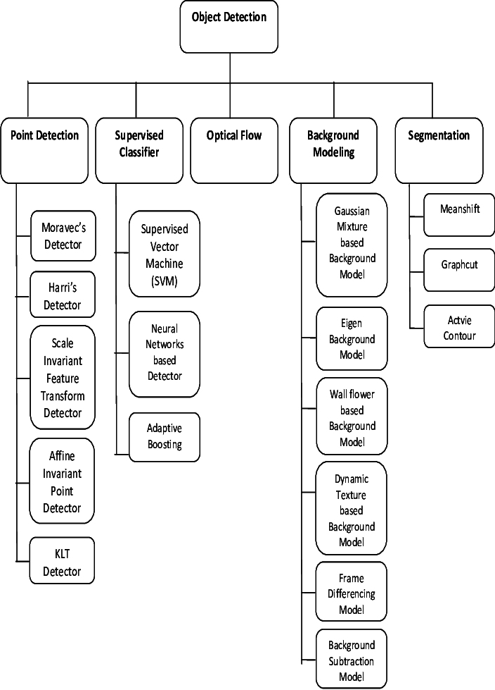

Object tracking methods:

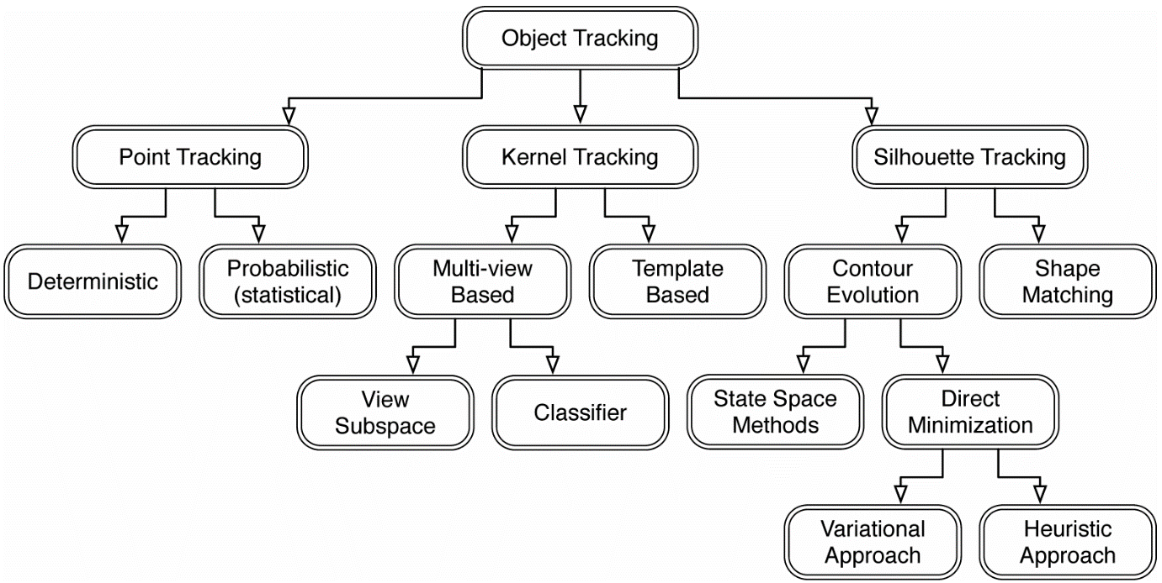

Discussion:

Today underwater vehicles are used to study remote the seabed most often with sensors acoustic. Optical sensors are more and more often embedded in these vehicles and the use of video is now widespread especially for short-term operations scope. Despite this, underwater vehicles are generally Manually directed by an operator. Treatment completely automatic videos is still very rare because it suffers the very poor quality of the underwater images. Indeed, because of the special optical properties of light in the water the images are very noisy, the lighting uneven, soft colors, and low contrasts. Furthermore, many parameters change these intrinsic properties water, including suspended particles, and videos submarines therefore have spatial variations and important temporal. In the goal of automatic processing of these underwater videos, it is therefore necessary, to apply a pre-treatment method before using the classical methods of image analysis.

References :

- K. R. Reddy, K. H. Priya and N. Neelima, "Object Detection and Tracking -- A Survey," 2015 International Conference on Computational Intelligence and Communication Networks (CICN), Jabalpur, 2015, pp. 418-421. doi: 10.1109/CICN.2015.317
-RITTSCHER, J., KATO, J., JOGA, S., AND BLAKE, A. 2000. A probabilistic background model for tracking. In European Conference on Computer Vision (ECCV). Vol. 2. 336–350.
-VEENMAN, C., REINDERS, M., AND BACKER, E. 2001. Resolving motion correspondence for densely moving points. IEEE Trans. Patt. Analy. Mach. Intell. 23, 1, 54–72
-TORRALBA, A. 2003. Contextual priming for object detection. Int. J. Comput. Vision 53, 2, 169–191. TORRESANI, L. AND BREGLER, C. 2002. Space-time tracking. In European Conference on Computer Vision (ECCV). 801–812.Alper Yilmaz, Omar Javed, and Mubarak Shah. 2006. Object tracking: A survey. ACM Comput. Surv. 38, 4, Article 13 (December 2006).
-REID, D. B. 1979. An algorithm for tracking multiple targets. IEEE Trans. Autom. Control 24, 6, 843–854.

