Project number: 1.1.1.2/VIAA/2/18/348
Full name: Mohcine Boudhane
Position: Researcher
Project title: The Study of Computer Vision Algorithms for Underwater Fish Inspection

Evaluation and comparative study of shape modelling methods
Shape analysis is an analysis of the geometrical properties of some given set of shapes by statistical methods. It allows to measure, describe, compare the size and shape of an object, in order to standardize these properties. Underwater images usually contain complex objects, which will vary in appearance significantly from one image to another. In this document we describe a comparative study of shape modelling methods in the state of the art.

The purpose of pattern recognition is to simulate the sensory perception activities of the brain. First, the visual and auditory perception, including in spectral bands not perceived by humans (infra red, radar, sonar, ...). Recognition needs a model of the object. For the human being, this model corresponds to a mental representation of the object that can be learned by retaining the most discriminating characteristics of the object. Characteristics can be all kinds of attributes of the object: shape, color, texture, size, volume, etc.
Study of shape could be considered as motion analysis. The definitions of the different motion classes are briefly described as follows (see figure bellow):
- Rigid motion preserves all distances and angles and has no associated non-rigidity.
- Articulated motion is piecewise rigid motion. The rigid parts conform to the rigid motion constraints, but the overall motion is not rigid.
- Quasi-rigid motion restricts the deformation to be small. A general motion is quasi-rigid when viewed in a sufficiently short interval of time.
- Isometric motion is defined as motion that preserves the distances along the surface and the angles between the curves on the surface.
- Homothetic motion is motion with a uniform expansion or contraction of the surface.
- Conformal motion is non-rigid motion which preserves the angles between the curves on the surface, but not the distances.
- Elastic motion is non-rigid motion whose only constraint is some degree of continuity or smoothness.
- Fluid motion violates the continuity assumption, too. It may involve topological variations and turbulent deformations.

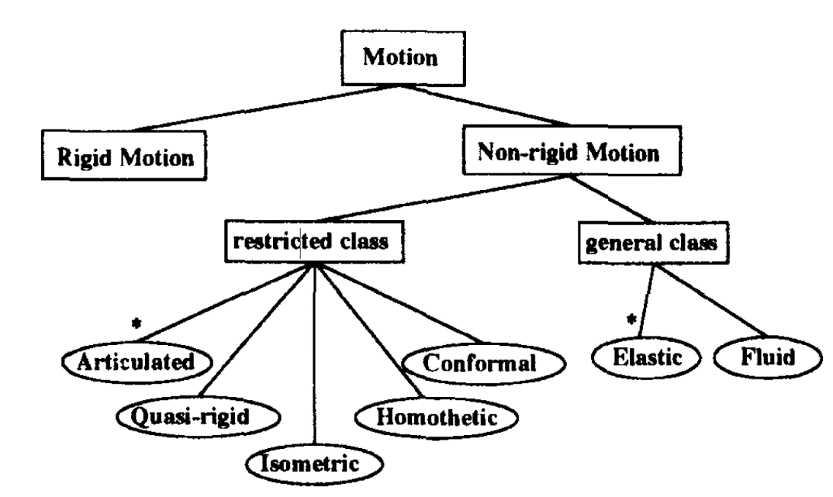

The challenges associated with face detection can be attributed to the following factors:
- Pose. The images vary due to the relative camera-face pose, and some features such as fin, dorsal may become partially or wholly occluded.
- Presence or absence of structural components.
- Fish features such as tails, head, mouth … may or may not be present and there is a great deal of variability among these components including shape, color, and size.
- Occlusion. fish may be partially occluded by other objects. In an image with a fish school, some faces may partially occlude other faces.
- Image orientation. fish images directly vary for different rotations about the camera’s optical axis.
- Imaging conditions. When the image is formed, factors such as lighting (spectra, source distribution and intensity) and camera characteristics (sensor response, lenses) affect the appearance of a face.

In general, there is a strong relationship between object representations and tracking algorithms. Object representations are usually chosen based on the scope of application. Objects can be represented by:

Objects can be represented by their shapes and appearances. In this section, we will first describe the representations of shapes of the objects commonly used for the follow-up, then we will treat the common forms, then we will finish this chapter by describing different representations of the appearance.

- Shape representation
  - Points :
We can represent the object by a point, this point is only the centroid of the object in question, so we can represent the object by a set of points. In general, the point representation is suitable for tracking objects that occupy small areas in an image.

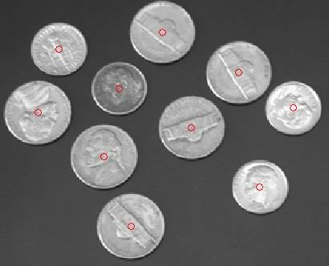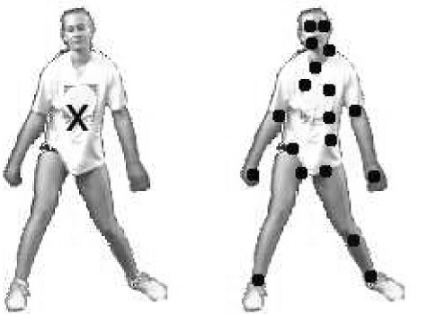
Figure1 : Representation of objects by points

  - The primitive geometric shape:
shape of the object is represented by a primitive form, for example: a rectangle, an ellipse ... etc. In this case, the motion representation of the object is usually modeled by translation, or affine transformation (homography). Primitive geometric shapes are more appropriate for representing simple rigid objects, they are also used for tracking non-rigid objects.

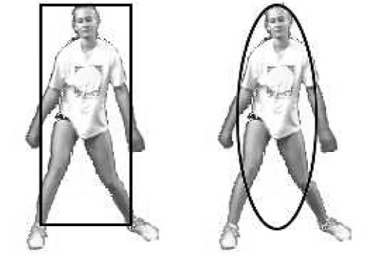
- (b)
Figure2 Objects representation by: (a) a rectangle and (b) an ellipse
1.3 Contour and silhouette of the object :
The contour representation defines the boundaries of an object. The region inside the contour is called ‘’silhouette’’ of the object. Silhouette and contour representations are appropriate for tracking non-rigid complex shapes.
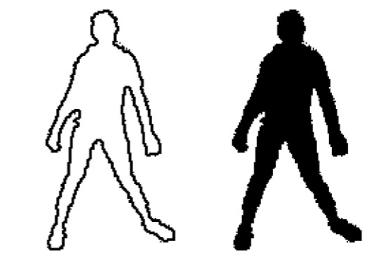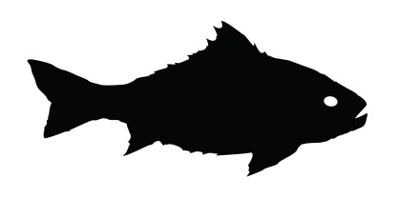
- (b)

Figure3 : (a) contour representation, (b) silhouette representation of objects
  - Articulated shape models:

Articulated objects are composed of parts of the body that are held together with a set of joints. For example, the human body is an articulated object with the torso, legs, hands, head and feet connected by joints. The relationship between the parts are governed by kinematic motion models. In order to represent an articulated object, the constituent elements can be modeled using cylinders or ellipses. (see figure4)

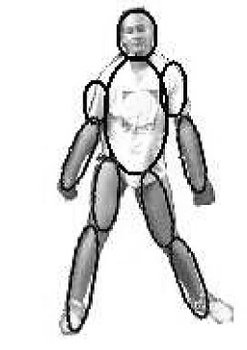
Figure5 : Articulated shape model

1.4- Skeletal models

The skeleton of the object can be extracted by applying the transform of the median axis to the silhouette of the object. This model is commonly used as a shape representation to recognize objects. The skeleton representation can be used to model both articulated and rigid objects.
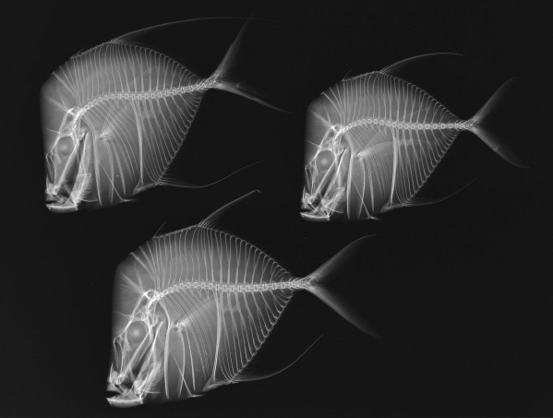
Figure4 : Skeletal models
Based on the several methods mentioned above, Table.1 includes some recent works for fish modelling.
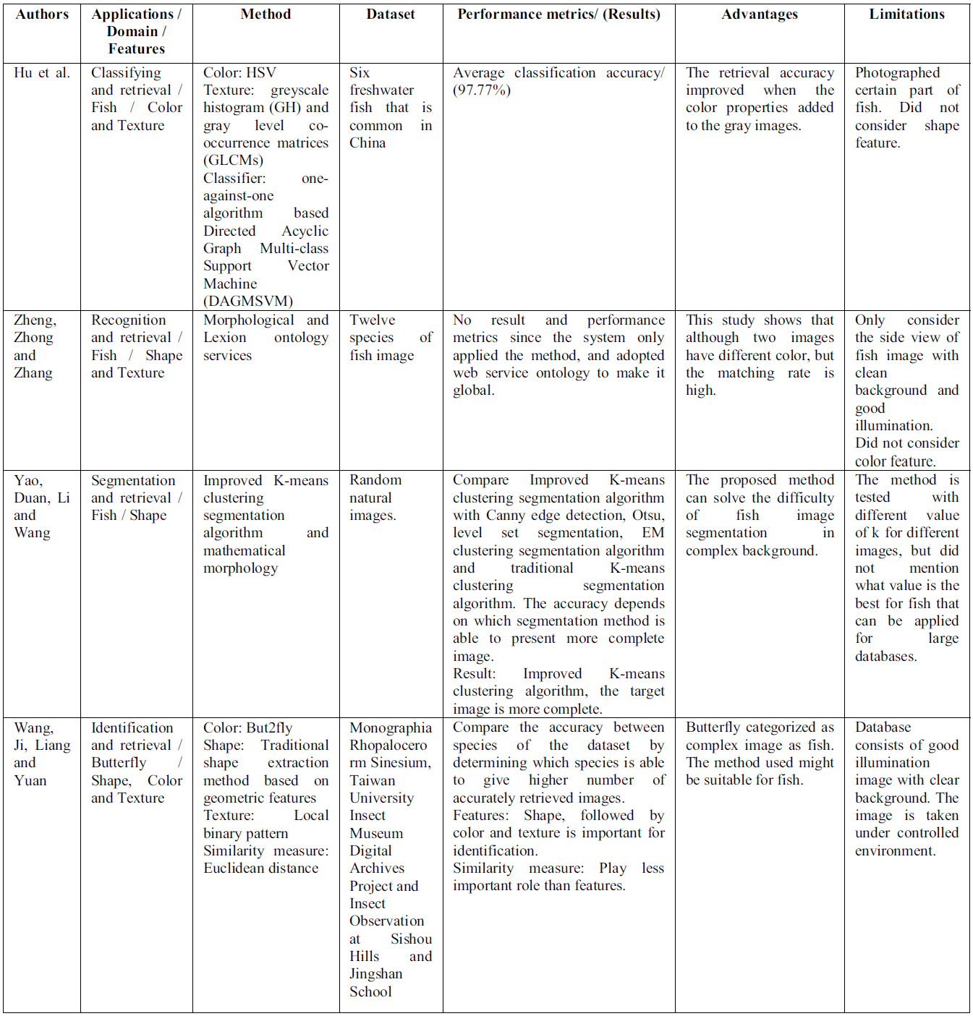
Table 1. State of the art methods for fish modelling

Discussion:
Fish shape modelling is a challenging and interesting problem in and of itself. However, it can also be seen as a one of the few attempts at solving one of the grand challenges of computer vision, the recognition of object classes. This shape admits a great deal of shape, color, and other variability due to differences in individuals, nonrigidity, tail shape, pose, and the environment itself. Images are formed under variable lighting and 3D pose and may have cluttered backgrounds. Hence, fish modelling research confronts the full range of challenges found in general purpose, object class recognition. However, fish species also has very apparent regularities that could be exploited by heuristic or model-based methods or are readily “learned” in data-driven methods.

References
J. K. Aggarwal, Q. Cai, W. Liao and B. Sabata, "Articulated and elastic non-rigid motion: a review," Proceedings of 1994 IEEE Workshop on Motion of Non-rigid and Articulated Objects, Austin, TX, USA, 1994, pp. 2-14. doi: 10.1109/MNRAO.1994.346261
Yilmaz, A., Javed, O., and Shah, M. 2006. Object tracking: A survey. ACM Comput. Surv. 38, 4, Article 13 (Dec. 2006), 45 pages. DOI = 10.1145/1177352.1177355 http://doi.acm.org/10.1145/1177352.1177355

J. Hu, D. Li, Q. Duan, Y. Han, G. Chen, and X. Si, “Fish Species Classification by Color, Texture and Multi-class Support Vector Machine using Computer Vision,” Computer Electronic in Agriculture, vol. 88, pp. 133–140, 2012.

X. Zheng, J. Zhong, and Y. Zhang, “A SOA-based Fish Recognition System Prototype,” pp. 66–69, 2011.

H. Yao, Q. Duan, D. Li, and J. Wang, “An Improved K-means Clustering Algorithm for Fish Image Segmentation,” Mathematical and Computer Modelling, vol. 58, no. 3–4, pp. 790–798, 2013.

J. Wang, L. Ji, A. Liang, and D. Yuan, “The Identification of Butterfly Families using Content-based Image Retrieval,” Biosystem Engineering, vol. 111, no. 1, pp. 24–32, 2012.

